Chip back potential is the level which bulk silicon is maintained by on-chip connection, or it is the level to which the chip back must be connected when specifically stated below. If no potential is given the chip back should be isolated.

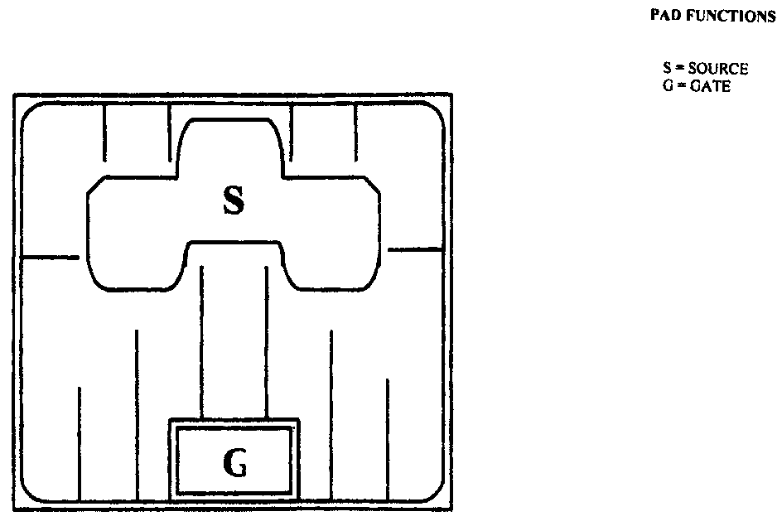
.259”
.259”

Top Material: Al
Backside Material: TiNiAg
Bond Pad Size: G = .035” X .066”
Backside Potential: Drain
Mask Ref: IX5X

APPROVED BY: DK DIE SIZE .259” X .259” DATE: 8/17/16
MFG: IXYS THICKNESS .015” P/N: IXGD32N60B
DG 10.1.2

Rev B, 7/19/02

